RESEARCH & DEVELOPMENT DEPARTMENT
ZOMBA DIOCESE
P.O. Box 115
Zomba - Malawi
Phone/Fax 01 526 919, 01 525 724
www.zombadioceseresearch.org
E-mail: director@zombadioceseresearch.org

CATHOLIC EDUCATION COMMISSION

BRIEF REPORT ON THE STATE OF DISASTER IN OUR CATHOLIC SCHOOLS

1.0: INTRODUCTION.

Following heavy and incessant downfall of rains which most parts of the country experienced during the two week period as from the 8th of January, 2015, there were floods in most areas and Zomba diocese catchment area wasn’t spared. As such, the diocese experienced flood disasters almost in all areas of development be it in health, livelihoods, social justice and education. This brief report therefore tries to analyze the state of affairs in some of the diocesan institutions which were affected either directly or indirectly.

2.0: THE ACTUAL STATE OF DISASTER.

The floods had caused inconveniences in a few diocesan institutions as teaching and learning had been interrupted and that the following was the actual state of affairs as reported and verified;

- So far, there had been no casualties of both learners and teachers in all the diocesan institutions.
- There had been a number of schools which had been used as places of refugee for displaced people. The following were the schools;
- Matandwe
- Sekwere
- St Paul’s Primary
- Pirimiti Boys
- Milala
- Katamba Primary
- Chinkhwangwa
- Matunduzi
- Bimbi

As I was compiling this report, learning situation had normalized as most people had resettled in other dry
areas close to their previous homes.
- Apart from the above mentioned schools being used as places of refugee, there was an exception of St Paul’s Community Day Secondary School which had all its classrooms damaged. As such, the institution is inhabitable and that led to the suspension of classes for a week. As a temporary measure, the school administrators liaised with their primary school counterparts and that they are currently using the primary school classrooms but during the afternoon only as the primary school learners are using the same classrooms in the morning.

3.0: HOW ZARDD (EDUCATION COMMISSION) REACTED.

3.1: Upon getting the information on the state of disaster in the affected institutions, Zomba Diocese Research and Development Department through the Education Commission solicited interventions of other stakeholders to come in and assist where possible. The main area of concern was the situation at St Paul’s CDSS where it was felt that things were out of hand and if left unattended, that would greatly affect the general performance of the school taking into consideration that forms 2 and 4 students were preparing their JCE and MSCE national examinations respectively.

One organization that responded and visited the area was the Catholic Women Organization through its diocesan Chairlady Dr Elizabeth Meke. Dr Meke who also works at Center for Education Research and Training at Chancellor College of the University of Malawi felt sorry for the girl child whom she thought was completely disturbed by the calamity. She then suggested for a visit to the institution and assess the actual damage so as to verify which areas needed immediate attention. She also wanted to get first hand information from the teachers and all those affected. We visited the school on the 28th of January, 2015. We first visited the school campus so that we could witness how floods had caused damage to the school infrastructures and observed the following:

A STATE OF DISASTER AT ST PAUL’S CDSS IN PICTURES

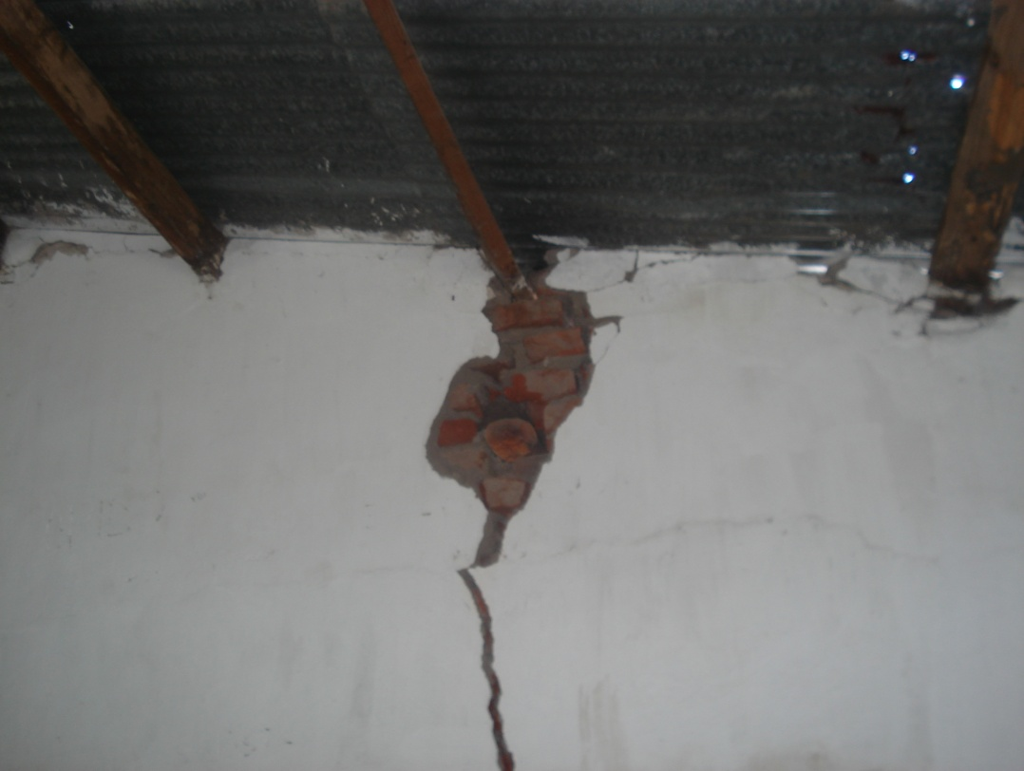
a cracked classroom wall (inside)

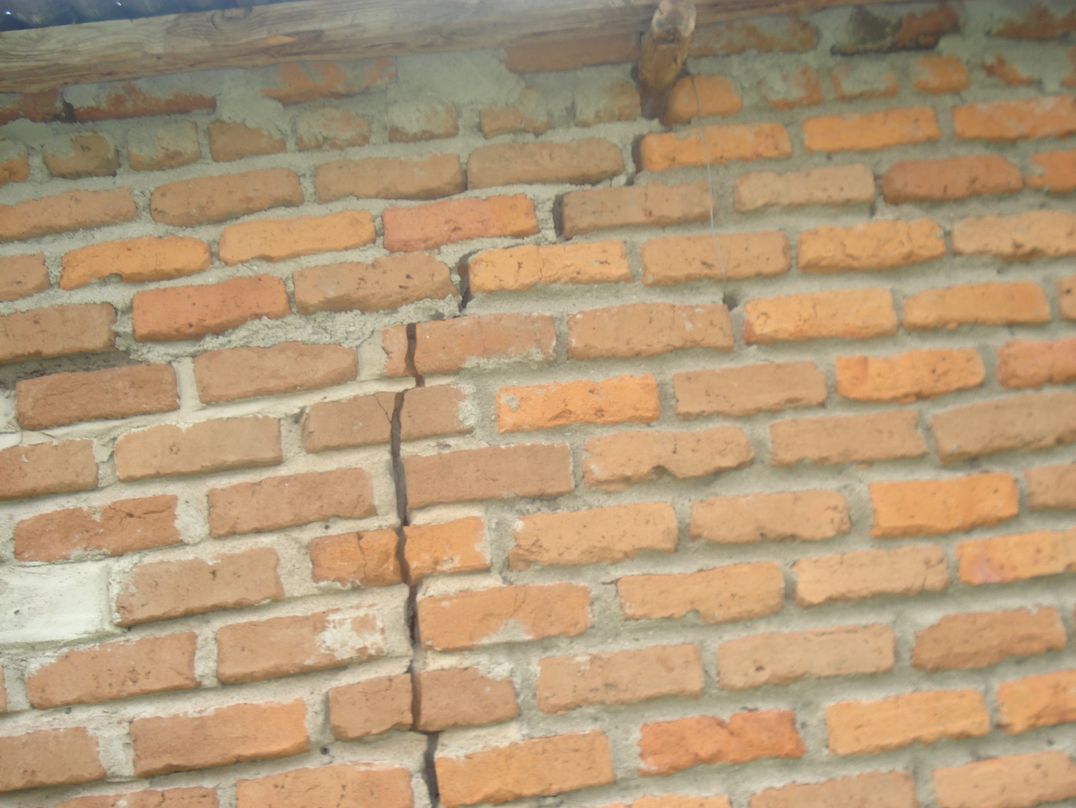
external crack of a classroom wall

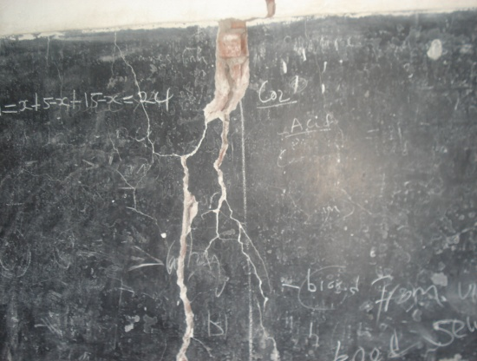
chalkboard with cracks unfit for use

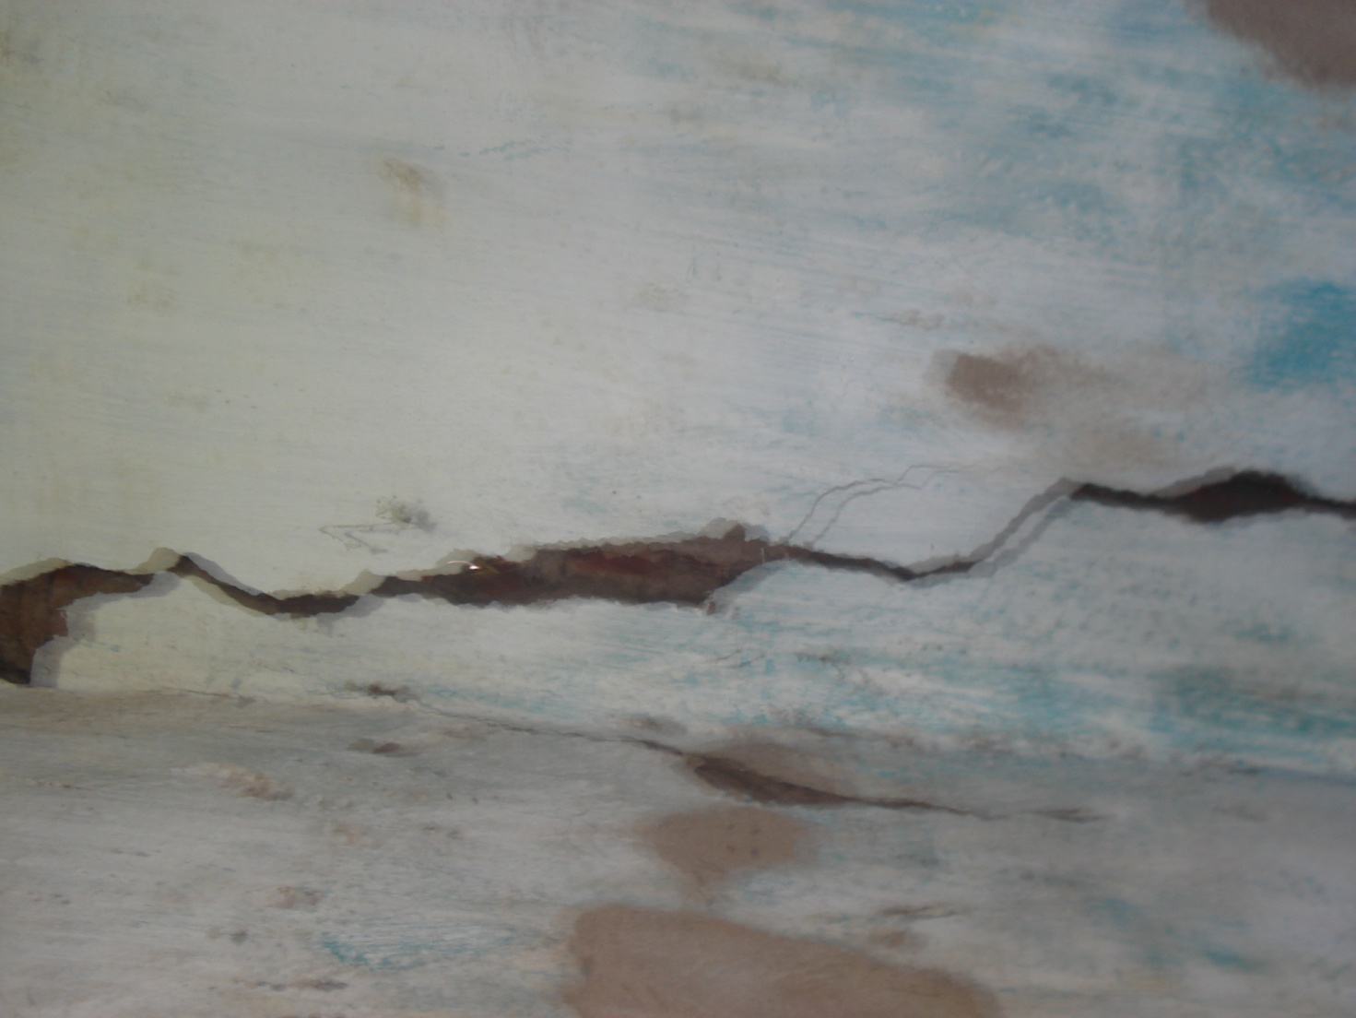
a damaged classroom floor with gullies
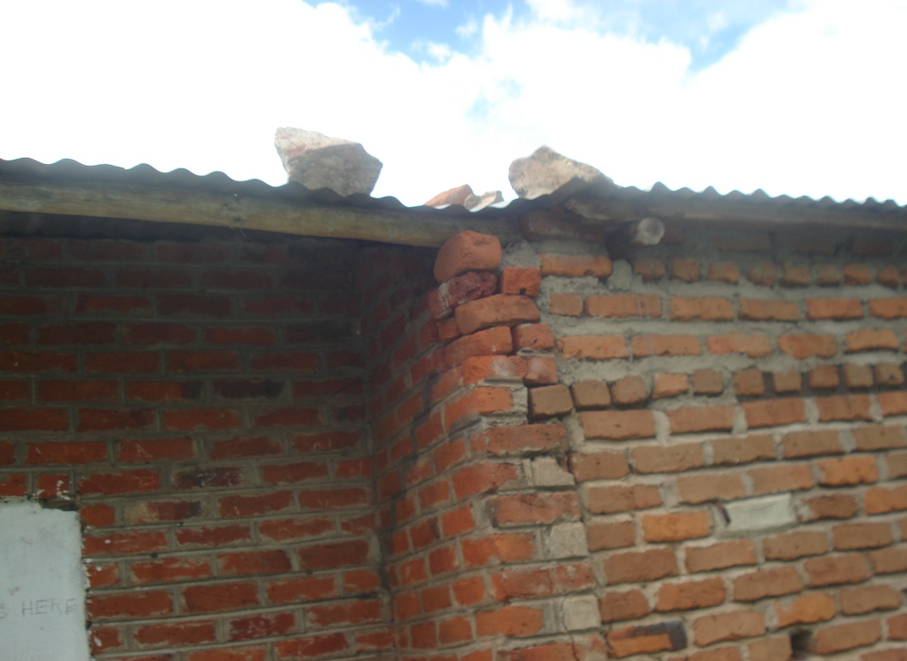
a block with some external damages

3.2: After assessing all school infrastructures, we had an audience with the PTA Chairperson Mr Chakolera who was around as we visited the school. Dr Meke wanted to find out what was it that they had done as a community to keep things move at the school. In his response, the Chairperson pointed out that as a committee, soon after the tragedy occurred, on their own initiative, they managed to:

- Report to the office of the Education Division Manager for South East Education Division for some assistance.
- Convene an emergency meeting with parents and other stakeholders especially the businessmen within the community to seek for joint effort.
- Seek assistance from the constituency development fund through the Member of Parliament for the area who only promised to take up the issue to the Local Assembly which till the day of our visit didn’t come back with any feed back.

He then finally said that despite all their efforts, none had come to their rescue and that there was no hope of getting any assistance as they felt that they had explored all the possible avenues. He reiterated that the only assistance that he and his committee were seeking could be tents which they felt could be used to make temporary shelter for classroom

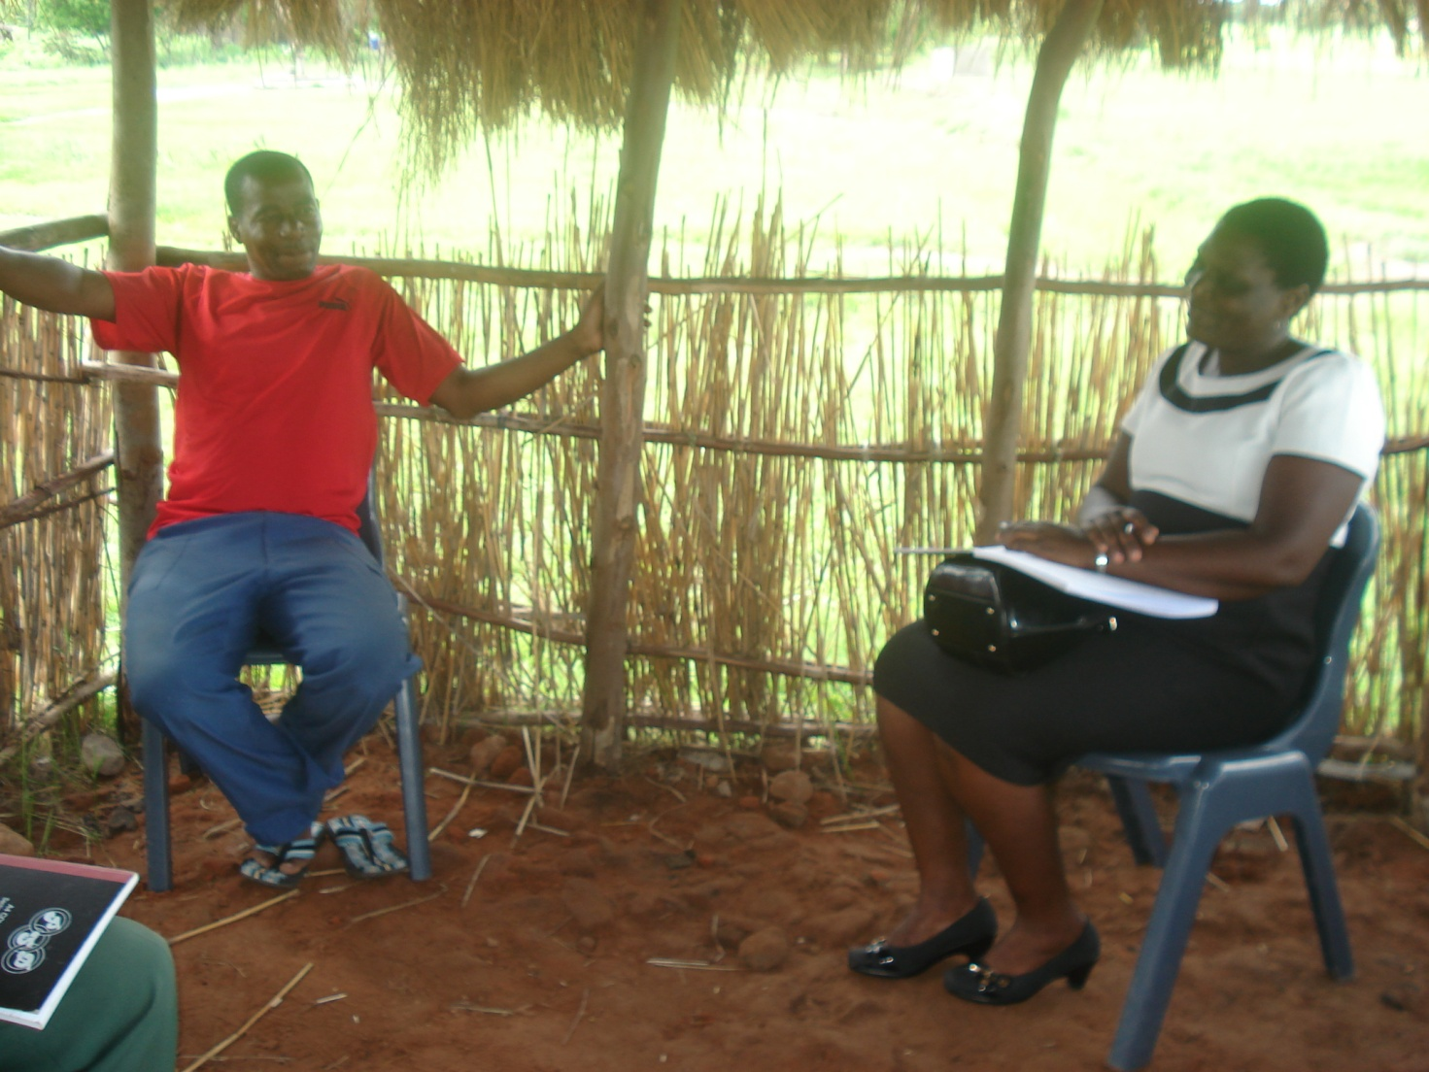
Dr Elizabeth Meke interacting with PTA Chairperson Mr Chakolera

3.3: The trip ended with a visit to St Paul’s Primary School where the displaced students were being accommodated for their afternoon classes. There, Dr Meke interacted with a few students and observed how teaching was conducted at what might be described as an educational refugee center. It was indeed very pathetic to see form four students lying on a bare floor learning. The situation wasn’t indeed learner-friendly as faces of students could tell the story as seen in the diagram below;
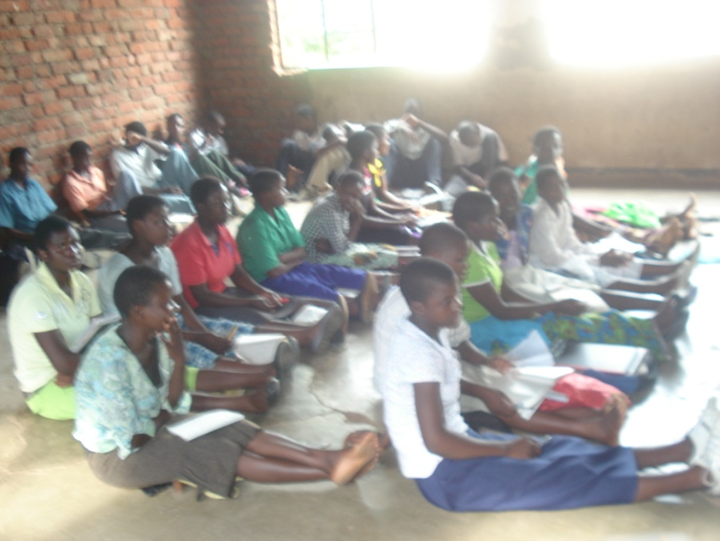
Form four students in a classroom situation

4.0: RECOMMENDATION AND WAYFORWARD

Having assessed the state of disaster at the institution and interacted with all the stakeholders at the grass root, Dr Meke commended the effort taken by the PTA Chairperson and his committee in an attempt to resuscitate teaching/learning situation at the institution. She however, expressed her willingness to support the committee in all its endeavors to bring back the situation to normal both at short and long term measures as follows;

- For short term measure, she promised to contact other non-governmental organizations such as Plan Malawi International and Action Aid that could assist in provision of tents as suggested by the PTA Chairperson.
- For long term solution, she emphasized the need to come up with some proposals hoping to identify both local and international organizations that could provide funds for either maintaining the damaged blocks or constructing new infrastructures.
- Dr Meke advised the PTA Chairperson to go back to the Member of Parliament for the constituency so that together with other businessmen for the area could mobilize themselves at least to come up with something little for the welfare of their children while waiting for other well wishers to come in.
- The PTA Chairperson thanked Dr Meke for sparing her time visiting the school for first hand information. He then pledged his support for every effort that would be provided towards the alleviating of the sufferings the students were experiencing. Being the first organization to visit and assess the damage, the Chairperson said was very optimistic that the visit would bear some fruits.

