A REPORT ON FLOOD RESPONSE
ZOMBA DIOCESE

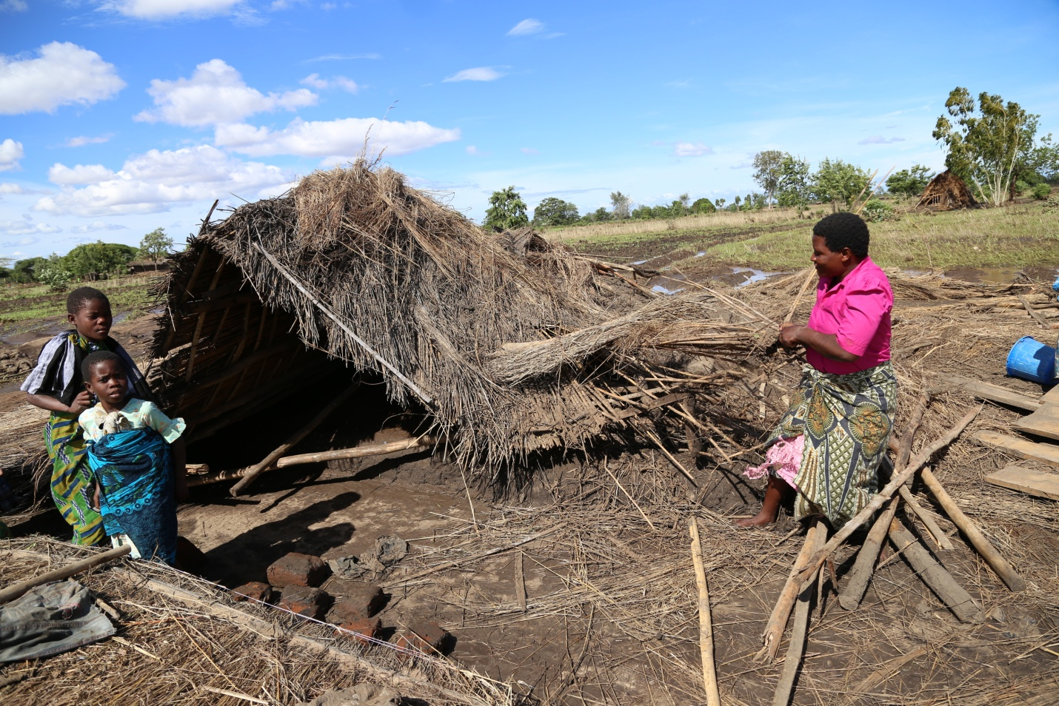
COMPILED BY : JOSEPHINE MAGOMBO MAME
PROGRAMMES COORDINATOR – CADECOM

CHECKED AND APPROVED BY: GEORGE PHIRI FR PETER MULOMOLE
CADECOM DIRECTOR ZARDD EXECUTIVE DIRECTOR

SITUATION OVERVIEW
Since early January 2015 the southern districts of Malawi have been experiencing above-normal rains, which have provoked massive floods along the Phalombe, Shire and Ruo rivers. Zomba diocese which covers the whole Zomba district and some parts of Machinga and Chiradzulo has not been spared. Preliminary reports from the assessments which were conducted in both Zomba and Machinga where Zomba CADECOM staff participated in, indicate that the floods have left at least 24,103 and 29,600 people displaced, (final numbers are still being verified) in Zomba and Machinga districts respectively, with 10 deaths in Zomba district. However, this number is expected to rise as more information is received and analysed, and rains continue to fall. The situation prompted the President of the Republic of Malawi to declare a State of Emergency on 13 January in 15 districts (out of a total of 28): Nsanje, Chikwawa, Phalombe, Zomba, Blantyre, Chiradzulu, Thyolo, Mulanje, Balaka, Machinga, Mangochi, Ntcheu, Salima, Rumphi and Karonga.
In most places, houses and crops were completely destroyed. This has left thousands of people homeless and more houses are collapsing as the rain continues to fall. The floods have damaged infrastructure, including roads and bridges. Most of the people displaced are living in displacement sites such as churches, schools, community buildings and camps (In total Zomba have 55 displacement sites). Some are hosted by relatives.
Emergency Assistance to Zomba Diocese in Response to the Floods Disaster
Zomba diocese with the support from Trocaire assisted 1600 households (900 from Machinga and 700 from Zomba). A total number of 492 households out of 2225 households supported through GPAF project in Machinga district were amongst those affected with the floods and were all supported with both food and non-food items. Trocaire assisted with 20,000 Euros and we procured 1000 bags of 50kg maize, 3200 plates, 3200 cups, 60 bags of beans and 280 black plastic sheets. The 1600 households affected were assisted with 25kg bag of maize, 2kgs beans, 10 metres black plastic paper, 2 plates and 2 cups each. Trocaire is scaling up its support to the affected populations who are desperate for safe water, food, shelter, medicines and other basic necessities.

Aid provided/pledged is falling far short of what is required. Zomba Diocese requires additional funding because the affected households/people needs continued support for some time like food, kitchen utensils, blankets and agricultural inputs.

Challenges
- There is a lack of basic services such as water, sanitation and hygiene, raising concerns over possible disease outbreaks.
- Registration at camps is not being consistently undertaken.
- Displacements camps are crowded raising concerns over possible outbreaks of airborne diseases
- Access to some of the displaced camps is difficult, because the roads are becoming impassable with the heavy rains.
- Students are not able to attend school due to their schools being flooded or occupied by those who require temporary shelters.
- Lack of health personnel in most Health centers and medical supplies to cope with the needs of displaced populations.

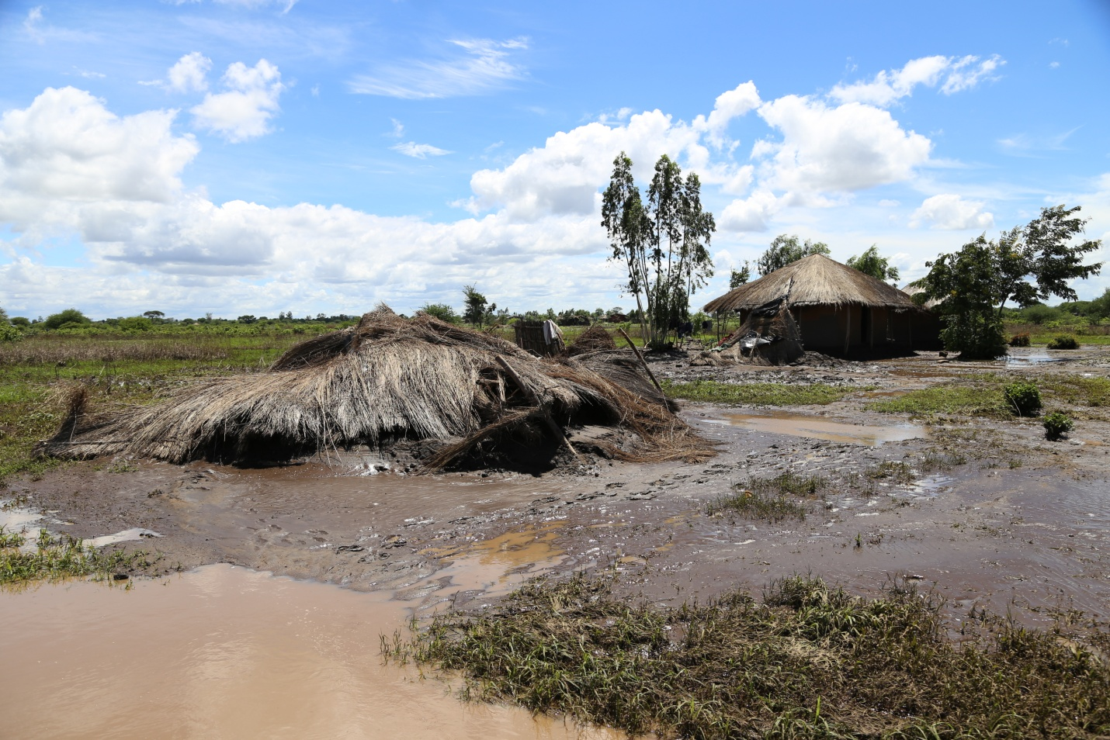
Chinkhwangwa village - Zomba

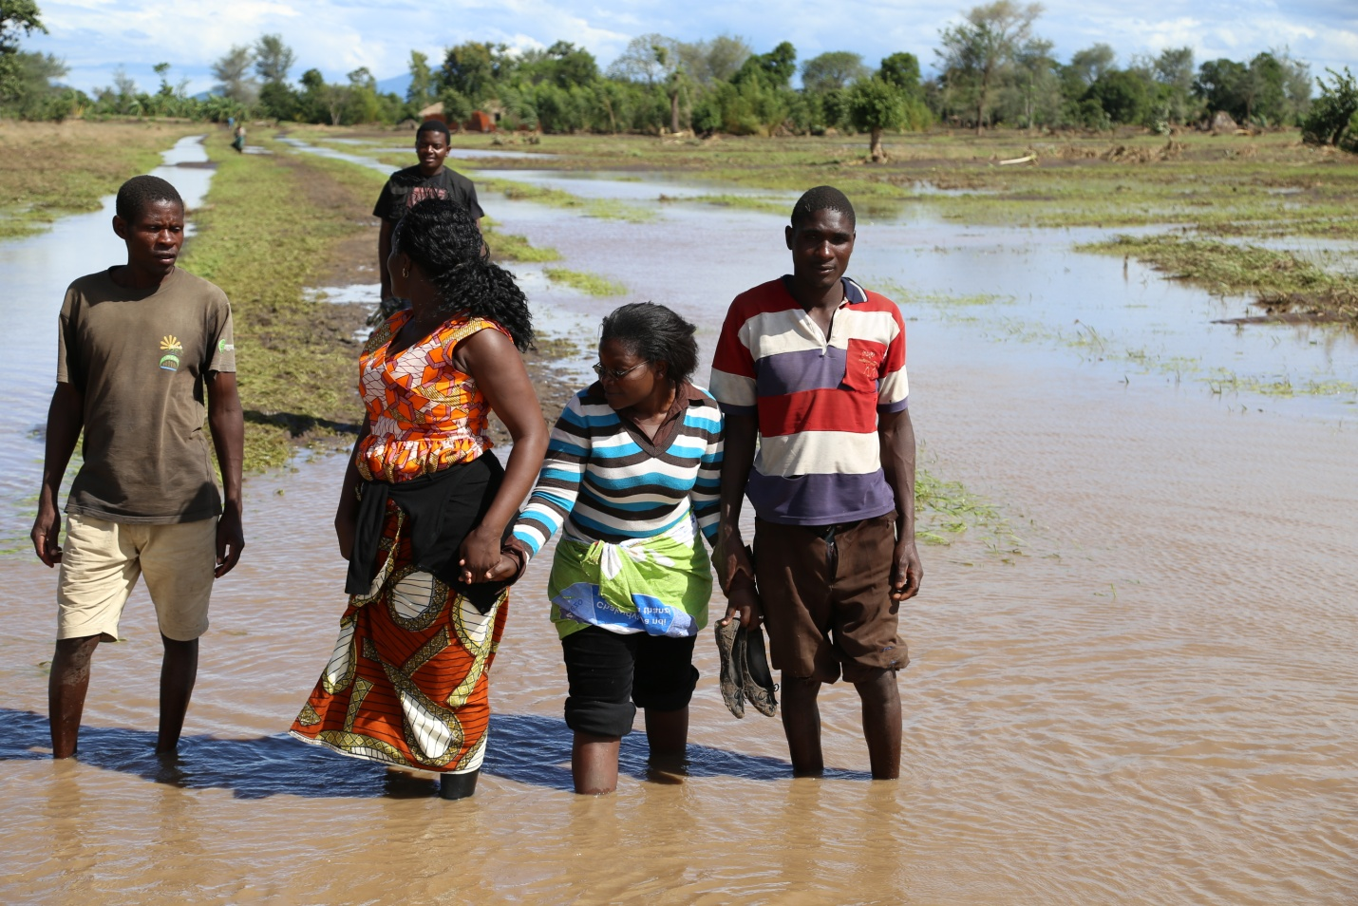
Road damaged – Bisimalichi village in Zomba
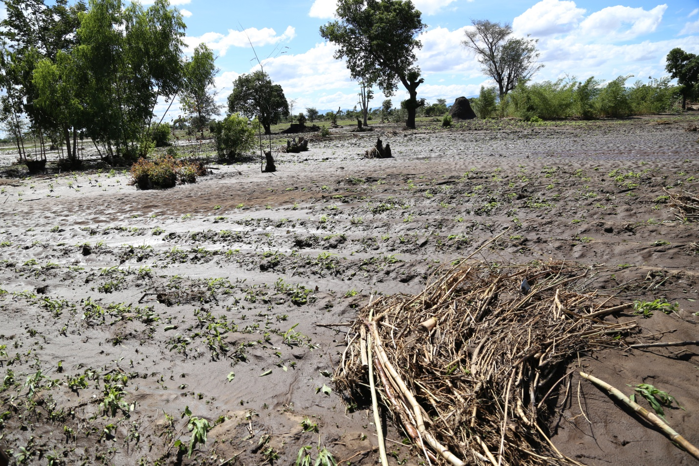
Maize field washed away – Machinga district
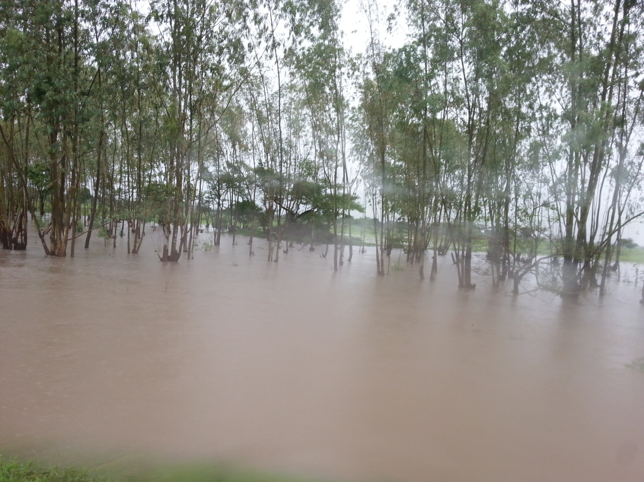
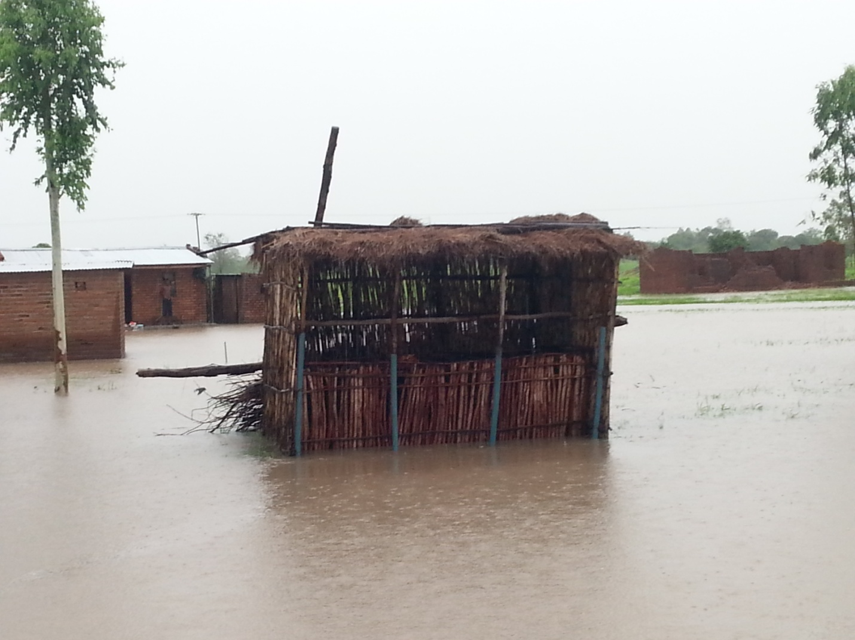
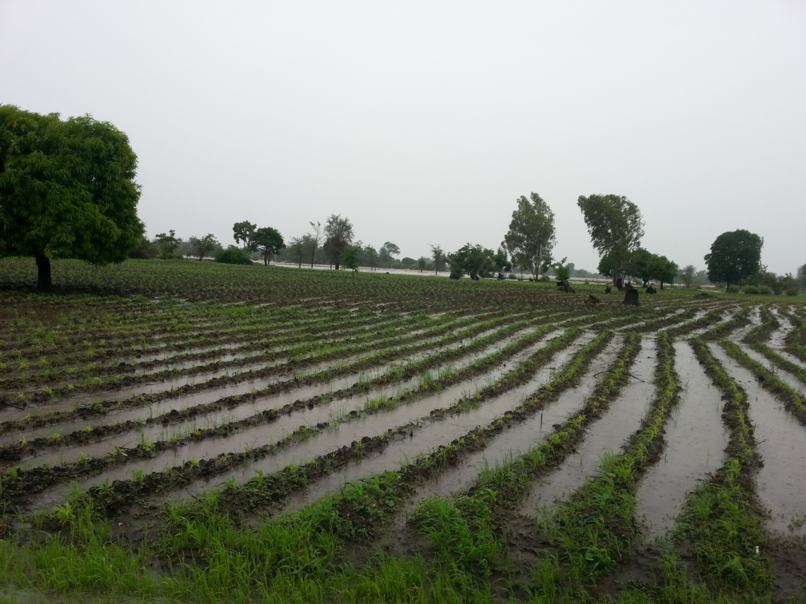
Maize field – Zomba district

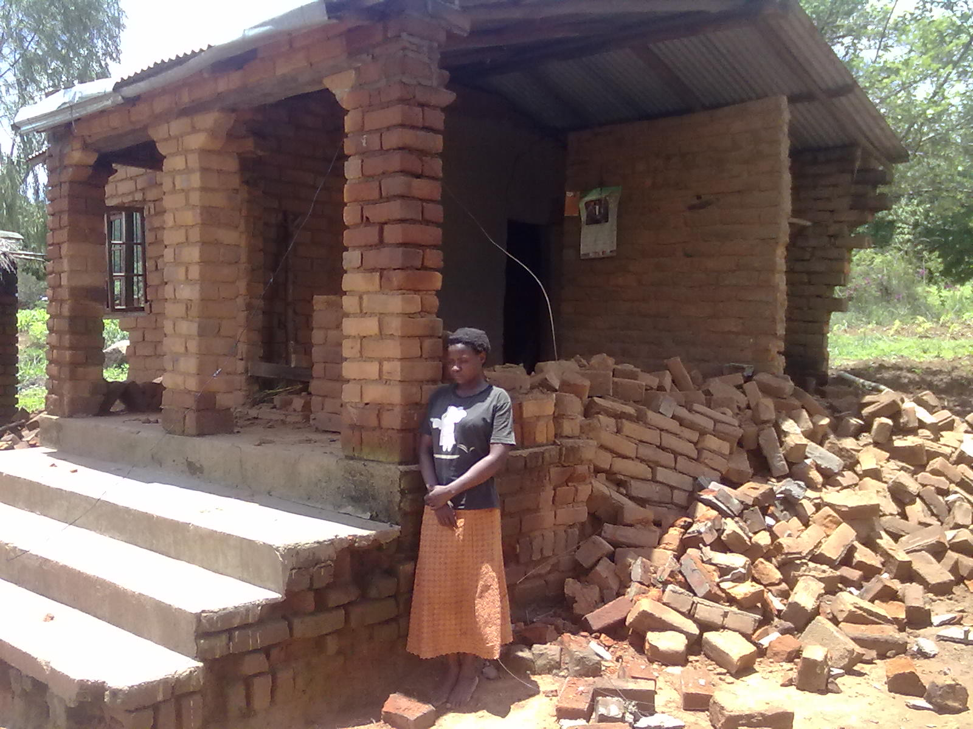

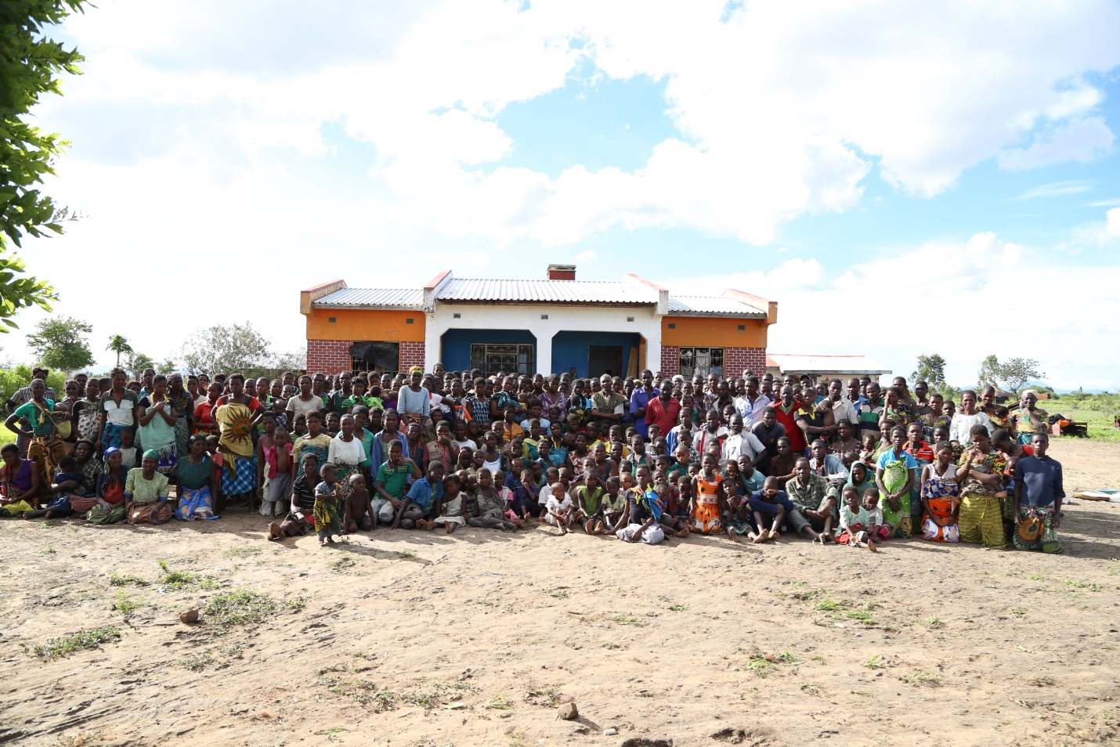
Affected hoseholds camping at a good samaritan house – Naphome village, GVH Magoli, T/A Mwambo in Zomba district

DISTRIBUTION OF RELIEF ITEMS IN PICTURES
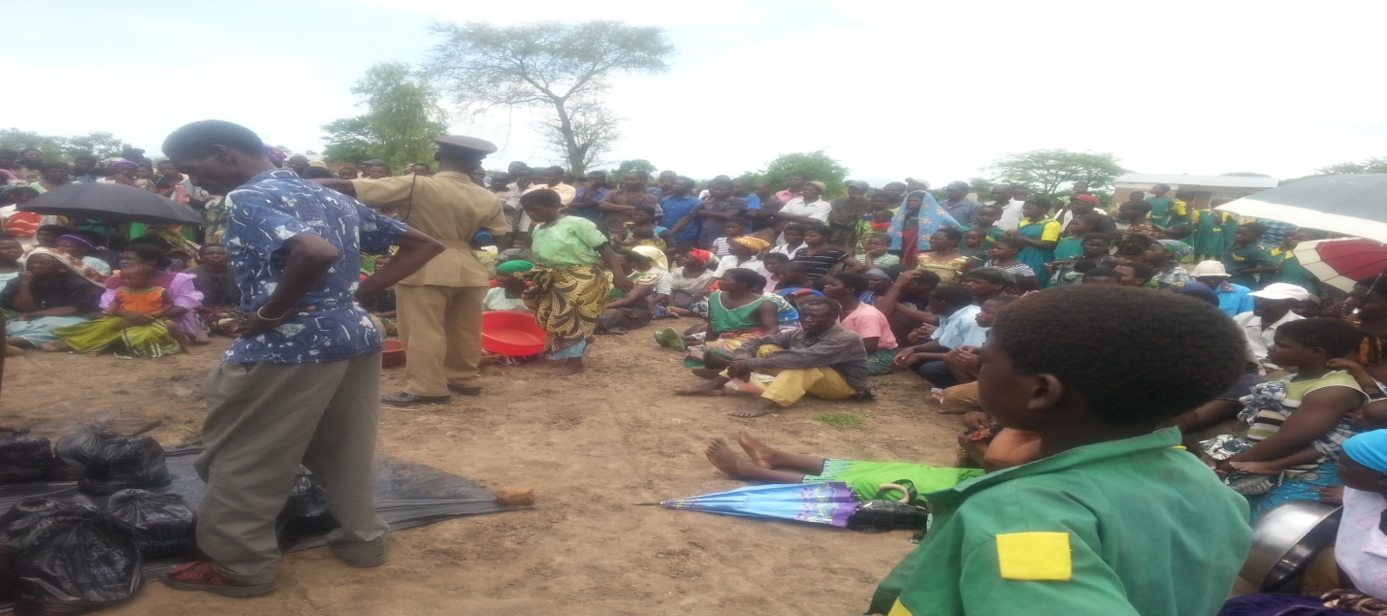

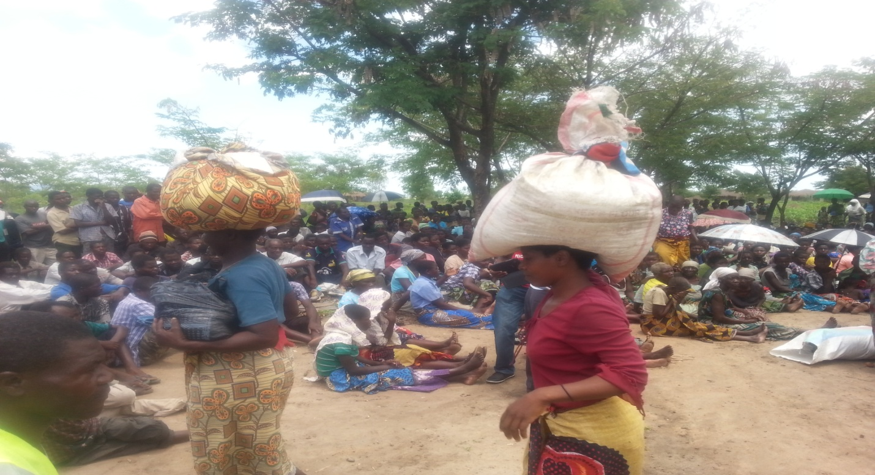
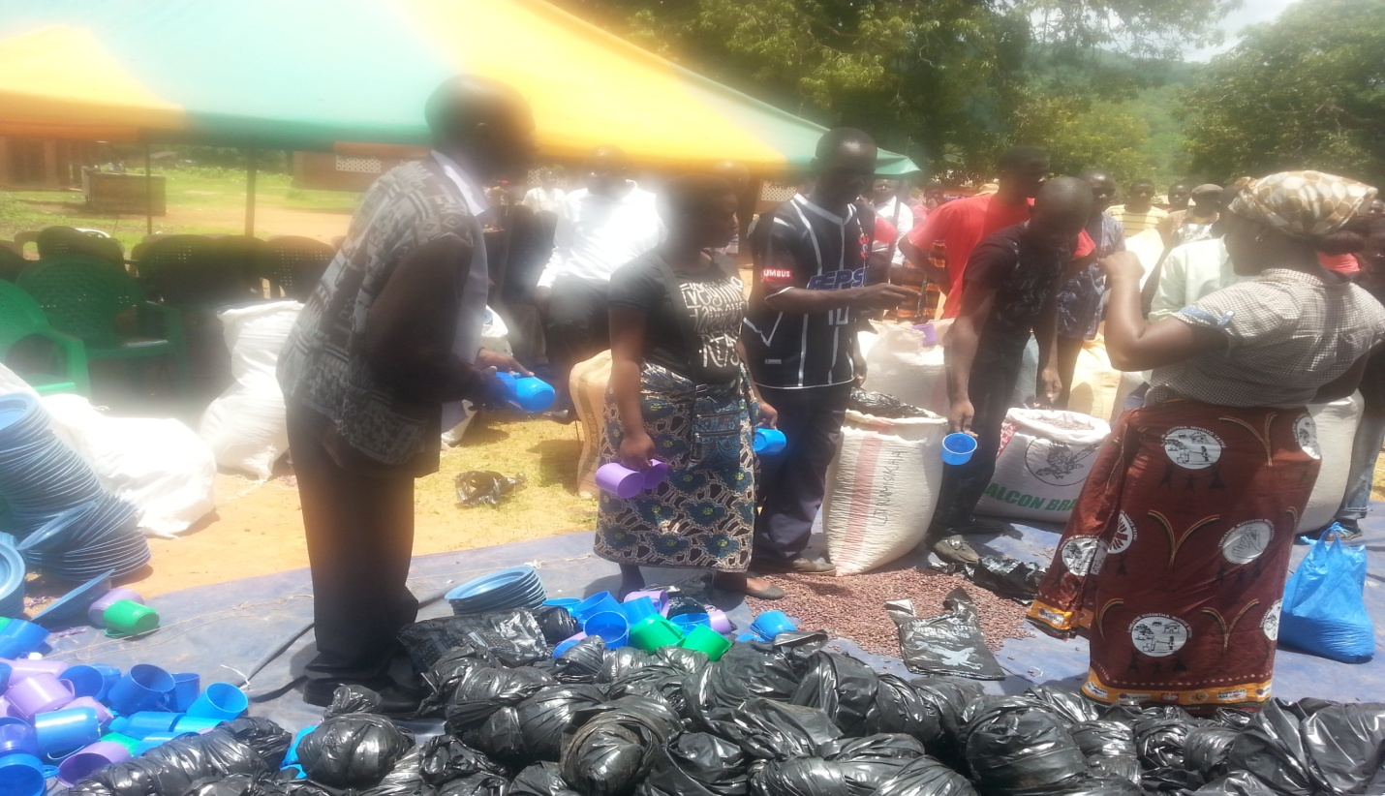

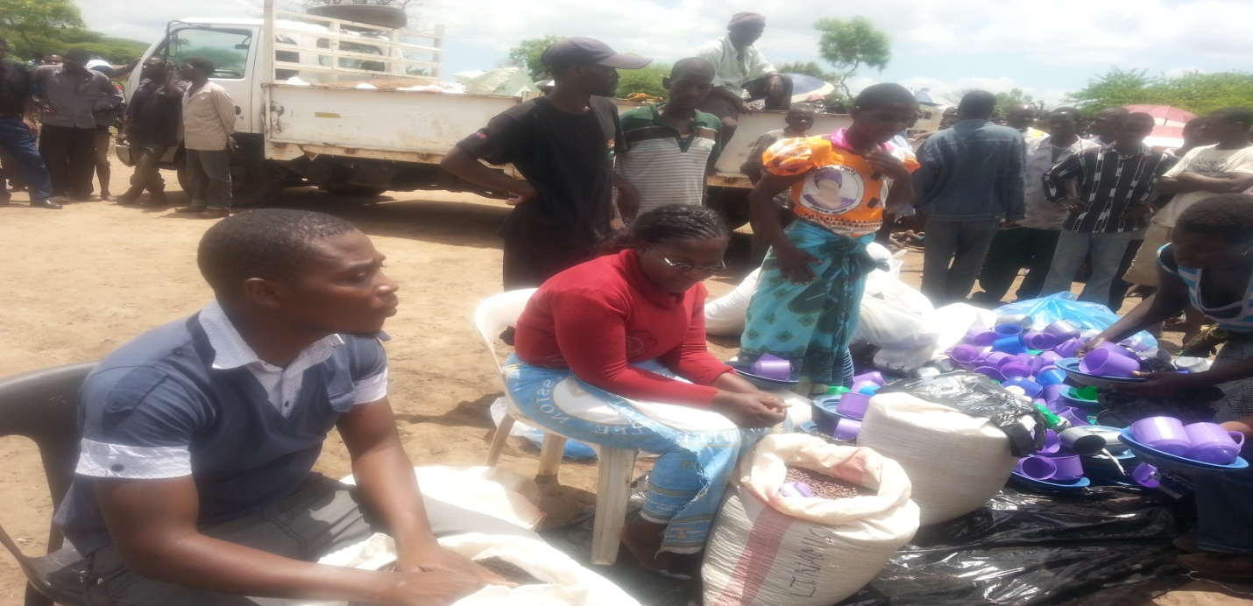
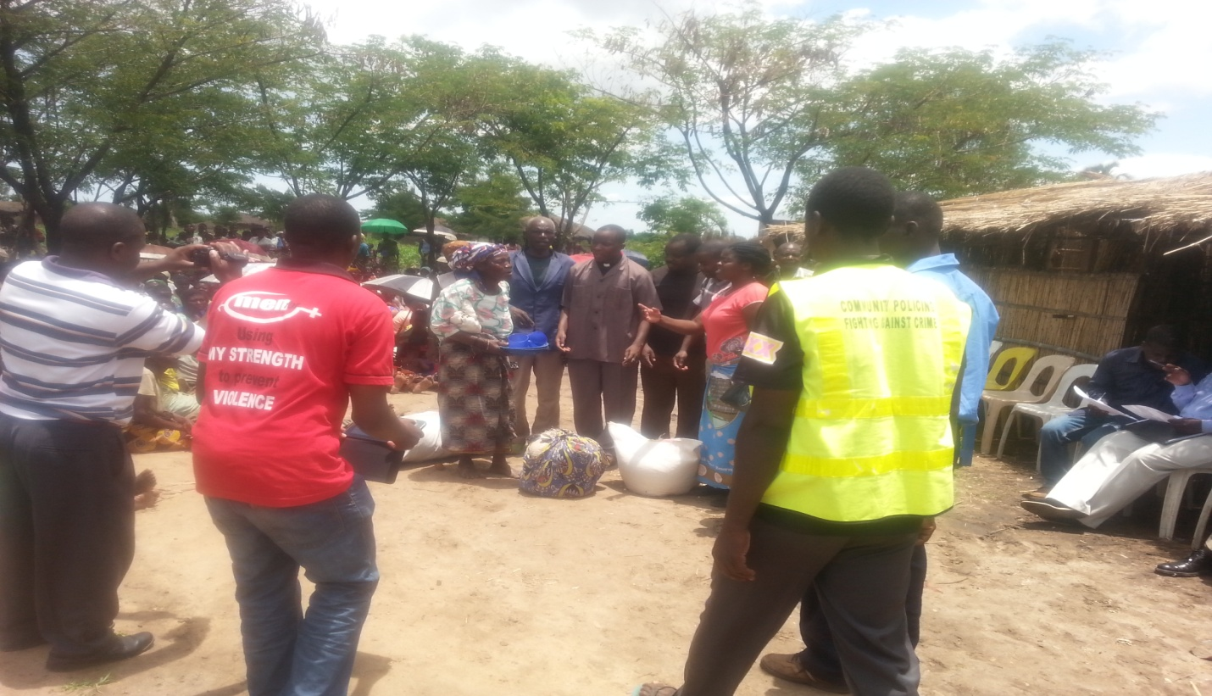
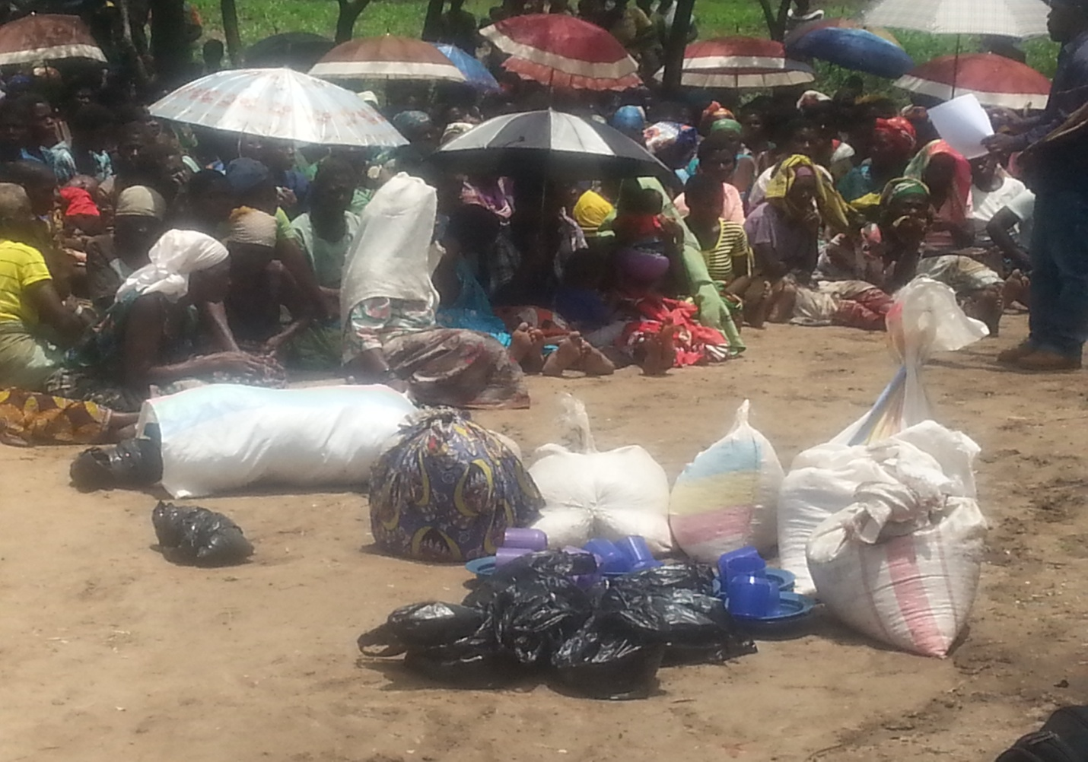

APPENDIX : LIST OF HOUSEHOLDS ASSISSTED IN MACHINGA AND ZOMBA DISTRICTS

